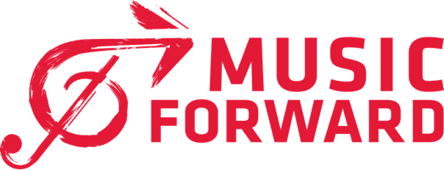

MUSIC FORWARD CELEBRATES NATIONAL APPRENTICESHIP WEEK WITH THE LAUNCH OF THE FIRST-EVER APPRENTICESHIP PROGRAM IN MUSIC AND LIVE ENTERTAINMENT RECOGNIZED BY THE DEPARTMENT OF LABOR
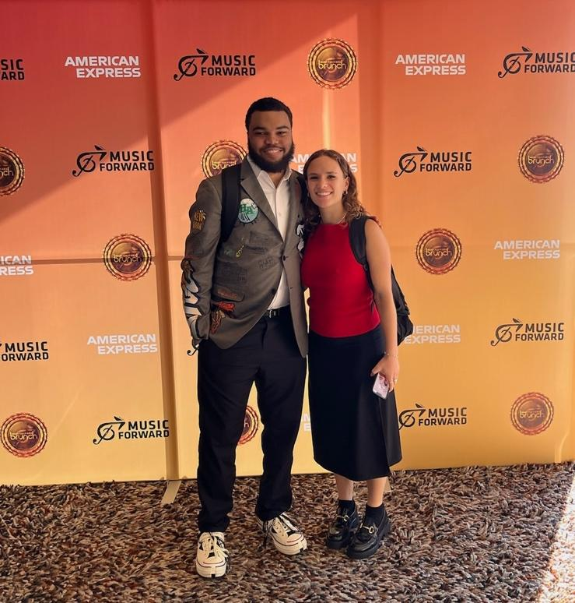
Apprentices Troy White & Chloe Colligan

NOVEMBER 18, 2024 – LOS ANGELES, CA - Music Forward, a national non-profit organization and Live Nation’s charity arm, proudly recognizes National Apprenticeship Week by celebrating its federally recognized apprenticeship program - the first of its kind nationally that focuses specifically on music and live entertainment. Apprenticeships bolster Music Forward’s mission to pave the way for the next generation of industry talent by helping young leaders transition from music enthusiasts into seasoned professionals via competitive training, professional development, on-the-job training, and mentorship and coaching. This innovative program is revolutionizing how young people from underrepresented communities gain the skills, experience and mentorship they need to thrive in one of the most dynamic industries in the world.

The journey to this first-ever registered apprenticeship in music and live entertainment began pre-pandemic via Music Forward harnessing its connections at the California Department of Education, community-based organizations, arts media and entertainment industry leaders BRIC Foundation (BRIC), Entertainment Equity Alliance (EEA) and Entertainment Industry Foundation (EIF) coming together to assess the role of workforce stakeholders in supporting a thriving and diverse arts and entertainment industry. This process led to the realization that registered apprenticeships are a vital part of preparing the next generation of industry professionals.

"This historic apprenticeship program bridges training, education, and high-skill, high-wage jobs in music and live entertainment, addressing challenges around building an inclusive industry and cultivating its long-term sustainability,” explains Music Forward Foundation Executive Director Nurit Smith. “With support from our employer partners, we are providing paid, hands-on experience to kick-start careers and drive economic mobility. This initiative is a critical addition to our work, our youth, and the industry we serve.”

These career paths are being built in partnership with high schools in the Centinela Valley Union High, Compton Unified and Los Angeles Unified school districts along with the California Department of Education’s Arts, Media, and Entertainment (AME) and Career Technical Education (CTE) industry sector schools plus Compton College - who are all teaching essential workplace skills, training students on creative processes and industry-standard technology and emulating professional environments to create authentic learning experiences for students. From San Francisco to San Diego, Music Forward works to reach young professionals, giving them the tools they need to launch successful careers in the music and live entertainment industries. Since its launch, Music Forward has received over 200 applicants interested in apprenticeships. Of those applicants, 92% are BIPOC and 61% female - ensuring the program supports underrepresented voices.

Music Forward’s competency-based apprenticeship program’s rigorous structure requires at least 1,080 on-the-job paid training hours coupled with mentorship and supplemental learning. It provides a vast breadth of apprenticeship opportunities in different pathways including Marketing, Special Events, Music Supervision and Talent booking as well as technicians in Lighting, Audio and Video (A/V) and production roles such as Grip/Rigger, Stagehand and Audio Engineering. Music Forward has partnered with entertainment industry heavyweights Live Nation, Wasserman, Bigger Hammer, Show Imaging, BRIC, Bulldog Event Group and others to provide a robust selection of apprenticeship placements where young emerging professionals receive training and experience to ensure they are poised for success. As the apprenticeship program grows, Music Forward seeks to bring in additional industry employer partners to continue expanding opportunities and build a bigger future together for young talent.

Music Forward’s current apprenticeship program participants are Gabriel Escalante & Kaije Rood at Show Imaging as Warehouse Techs, Chloe Colligan and Troy White at Wasserman in Talent Coordination and Marketing respectively, Emily San Vicente at BRIC Foundation in Marketing and Breanna Flores at Music Forward in Special Events.

“My experience has been incredible,” raves Wasserman apprentice Troy White. “My team has taught me tour marketing from the ground up, and my main takeaway is that being detail-oriented is the key to success in the agency space, no matter what department you are in, along with ambition!”

Wasserman apprentice Chloe Colligan enthuses, “The experience has been really amazing, and I am so grateful for this opportunity! I think the main takeaway for me is seeing how the music industry operates first-hand, and it honestly surpassed my expectations.”

Ensuring a strong foundation and necessary resources, Music Forward’s apprenticeship program has received remarkable government support including being the recipient of a $500,000 California Opportunity Youth Apprenticeship (COYA) grants, one of the only dedicated to careers in the creative economy.

Governor Gavin Newsom’s dedication to Music Forward’s apprenticeship program is exemplified by his statement: “California is committed to helping disadvantaged youth prepare for high-quality careers. Through our nation-leading career education efforts, we’re boosting apprenticeships throughout the state and across industries to help young people launch into the right career for them.”

Along with the COYA grant, Music Forward has secured nearly $1M in multi-year support for this initiative from the Irvine Foundation, the South Bay Workforce Investment Board, California Workforce Development Board and High Road Training Partnerships. These funds will allow for youth and employer incentives, education stipends, mentoring and training for careers in the creative economy.

National Apprenticeship Week: November 17-23, 2024, is a nationwide celebration where employers, industry representatives, labor organizations, community-based organizations, workforce partners, educational institutions, and Federal, State, and local government agencies host events to showcase the successes and value of Registered Apprenticeship for strengthening our economy by developing a highly skilled workforce to meet industry needs, creating pathways for career seekers to catapult into good jobs, and advancing racial and gender equity. National Apprenticeship Week gives registered apprenticeship sponsors the opportunity to showcase their programs, facilities, and apprentices in their community. To learn more about Music Forward Foundation’s apprenticeship program, visit HERE.

About Music Forward:
Music Forward transforms young lives, inspires careers, and champions a more inclusive music industry. The organization bridges communities to the music industry, empowers ambition, and creates momentum to redefine what is possible for the youth and industry we serve. Over the past 30+ years, the Music Forward Foundation has served over 1 million young people and provided more than $42 million in scholarships, workforce opportunities, and relief funds. Music Forward is the evolution of the International House of Blues Foundation, which began in 1993. Acclaimed artists Phoebe Bridgers, Trombone Shorty, and Andrae Alexander are past program participants and grant recipients. Performers Kahlid, Sophia Carson, Lauren Daigle, Martina McBride, Carlos Santana, and Julia Michaels have served as ambassadors for Music Forward. www.musicforwardfoundation.org

Contacts:
Anna Loynes & Renee Harrison / Scoop Marketing:
aloynes@solters.com / rharrison@solters.com

